1. **Git-HOL**

Step 1: Setup your machine with Git Configuration

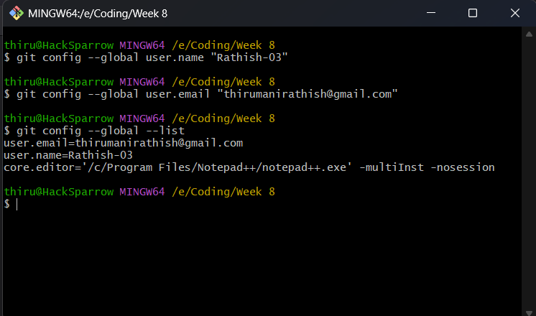

Step 2: Integrate notepad++.exe to Git and make it a default editor

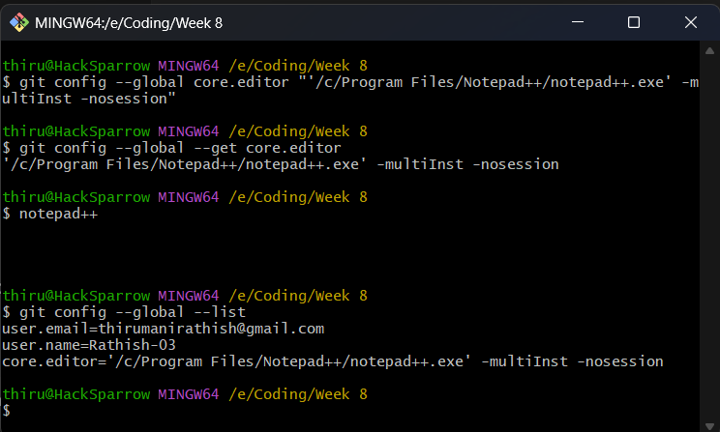

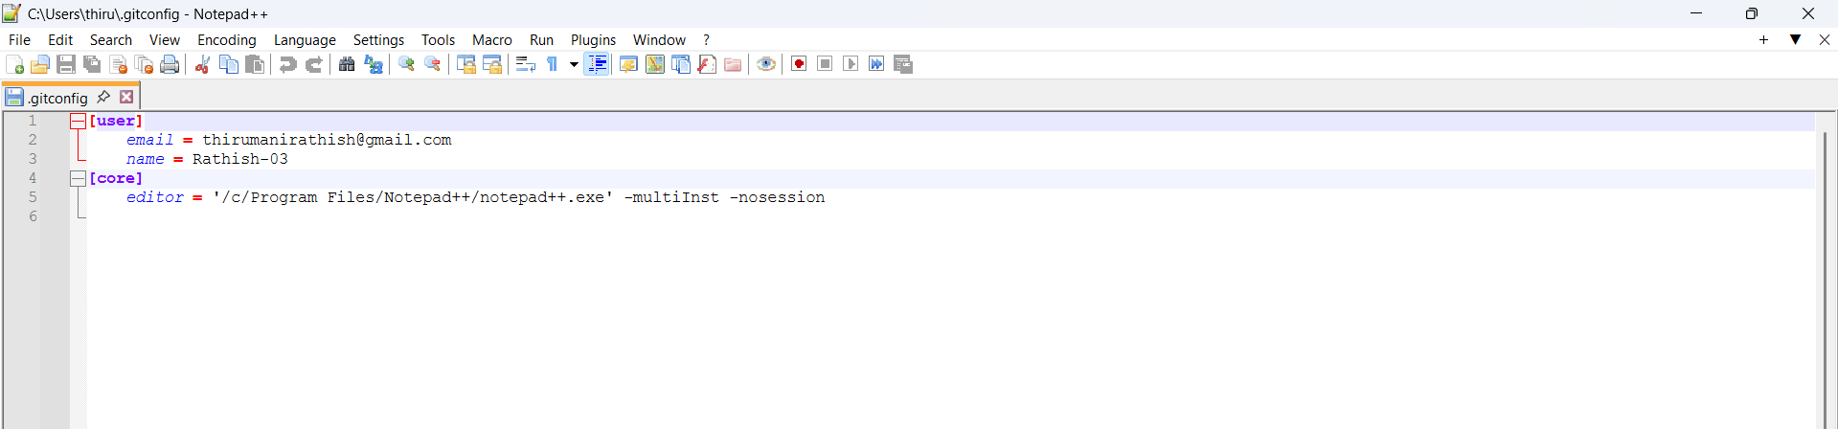

Step 3: Add a file to source code repository

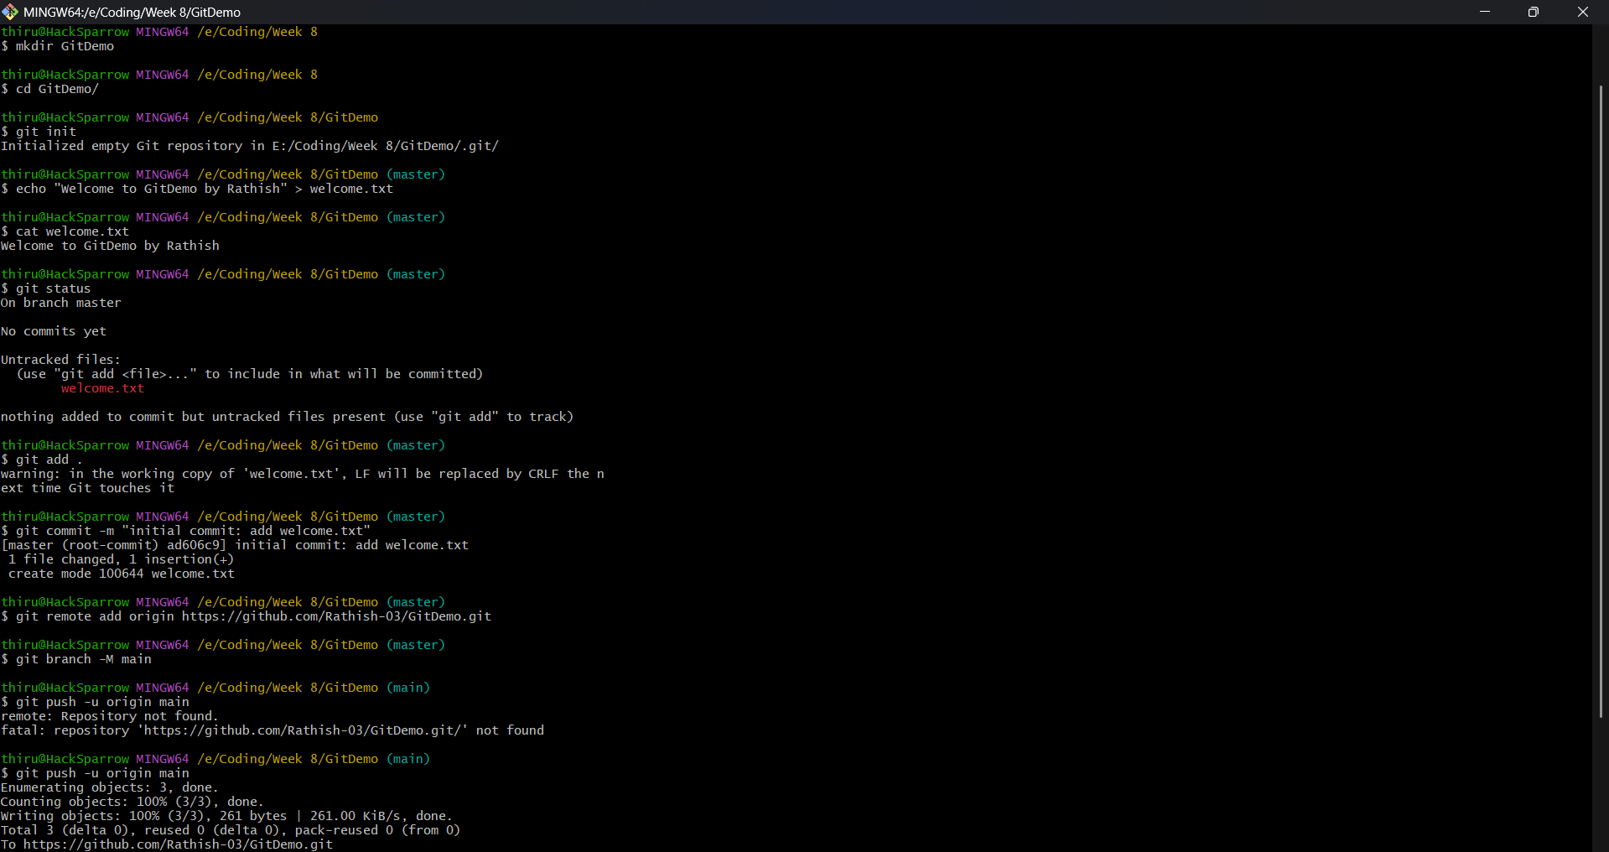

Step 4: Signup with GitLab and create a remote repository “GitDemo”

